An Argument Against the GLBR

Dalton Jackson
4/18/2016
“Neither a wise man nor a brave man lies down on the tracks of history to wait for the train of the future to run over him” – Dwight D. Eisenhower.
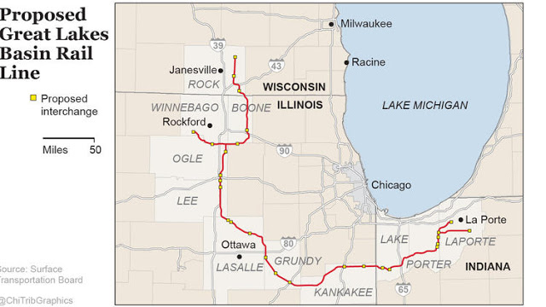
Eisenhower’s quote couldn’t hold more truth, especially when the train is real, and runs directly through many people’s lives. The Great Lakes Basin Railroad, a proposed 278 mile rail system that aims to bypass existing railways to “avoid rail congestion,” plans to cut through many acres of farmland- disrupting the ecosystem, farming, and families standing in its way. The opposition to this railroad has been large, passionate, and very vocal. Yet, Frank Patton, the GLBR founder, continues his campaign against the hard working farmers. It seems that some may not care for these people connected to their land through labor and generations of heritage attached to it, but perhaps they might care about the other impacts the GLBR will have. It will affect the diverse ecology present all throughout the Midwest. It will affect the local economies it passes through. Railroads have been established for some time, and thankfully there is plenty of evidence to support the opposition to them.

The Railroad Route in Question (Proposed).

The railroad plans to connect South-Central Wisconsin to Indiana, and disrupt all the farms and wildlife between. In addition to fertile farmland, there are numerous diverse ecosystems, consisting of a large variety of plant and animal life, present along the planned railroad. Wildlife and farmers have been living mutually together for many generations. Many of these farmers are active in the herd monitoring of white tailed deer and wild turkey, the preservation of various migratory birds, and the continuation of many plant species. The farmers do this all while supplying the world with food. The railroad would be very detrimental to the many ecosystems present: rails break up habitats and create barriers; the noise, light, and vibration pollution caused by trains would scare and disrupt many natural processes; the farmland would be broken up and ruined; and train collisions with wildlife (as well as cattle and even people) present a danger to lives (Ree et al).

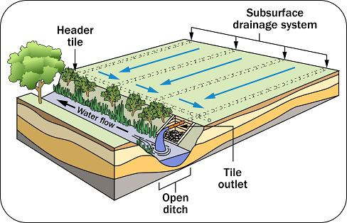
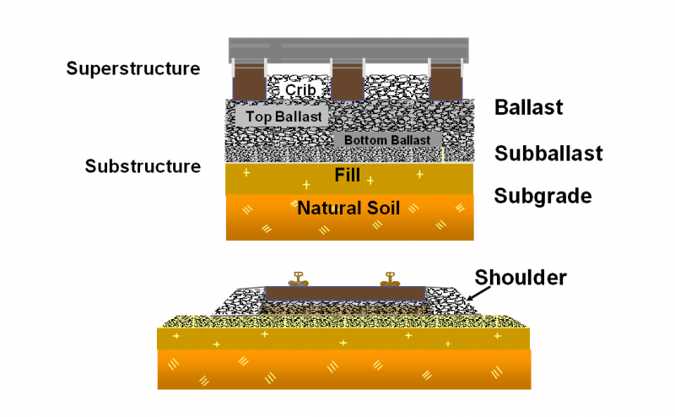
The majority of the 278 miles the train plans to cut through appears to be farmland. Whole farms will be cut in half, separated not just by the tracks, but also the 200 foot right of way. A square acre is approximately 43,560 square feet (208.71 feet x 208.71 feet), so whatever acreage the railroad crosses, the owner would be left with about 75 square feet of that acre. The total area affected by the 278 miles of track will be at least 6,740 acres. That is a lot of lost farmland. However, that is not the only problem for the farmland. Many of the agriculture fields affected by the railroad use a tile draining system. This system uses underground pipes and plumbing to keep subsurface water levels optimal for crop growth. The plumbing typically drains in a water source near by the field with the tile typically being laid at depths between 2 to 6 feet below the surface (Wright). This becomes an issue for the GLBR construction. Railroads are built in layers, with the deepest layer going deep in the ground to provide a stable base for the rest of the layers. This layer is known as the subgrade layer and is typically about 15 feet in depth (Track). That means a substantial of tile is in the way of this railroad project. Why is this a problem for the GLBR? Patton himself said that if the tile plate is in jeopardy, he will not be permitted to build the railroad (Stevens).
Layers of a Railway (Basic). Typical Tile Drainage (Vander Veen).

Railroads affect more than just farmland, the ecosystems are also in danger. Railroad tracks create unnatural barriers that fragment the habitat into smaller sections. This often decreases biodiversity and disrupts the natural balance. Animals that are used to open land are suddenly closed in. Smaller species of animals, such as turtles, rodents, and snakes are unable to cross the tracks to get to other parts of their habitat. This would cause the population of such species to decline, as well as every animal higher on the food chain. Sure, there is always the possibility of adding crossing structures, however this would be ineffective -Unless the railroad plans to incorporate 278 miles of crossing structures.

The physical barrier is not the only problem associated with trains, there is also noise, vibration and light barriers. It’s no secret that trains are extremely loud and cause vibrations. These create scare-barriers for typically cautious wildlife, and would present the same risk to population as the physical barriers present. The noise and vibrations would push these animals away from wherever the tracks are present, and into an even smaller habitat. It can also disrupt mating and reproduction habits. A study done in the Netherlands correlates the decline of their bird population to the noise and presence of the railroad system (Waterman et al). The threat posed to these animals’ increases as the number of trains increase. Patton estimates a maximum of 110 trains per day (approximately 4 to 5 trains an hour) it should be evident that the impact on the wildlife population would be detrimental.

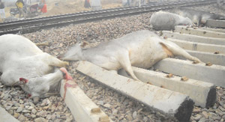
Not only are trains loud, they are also fast and heavy. Because of this, they carry a lot of momentum and are extremely difficult to stop. The average freight train traveling at 55 mph requires more than a mile to come to a complete stop (Minnesota). If the conductor applies the emergency brake to stop for anything, they better hope that the obstruction is more than a mile away. That is if the train conductor even decides to apply the brakes. For most scenarios, it is not worth the hassle of stopping a train for some animals on the track. The train can cut through any animal, and even herds of animals, like a hot knife through butter. This is not only hazardous for the wildlife, but also for the cattle grazing the lands which the railroad plans to rip through.
Cattle Slain By a Train (Cattle).

There is no shortage of news articles documenting the fatality of trains colliding with herds of animals. A quick internet search will yield thousands of articles, pictures and even videos of the damage caused by train collisions. One such incident occurred in rural England, where a train was derailed after striking and destroying a herd of 10-12 cattle (Kent). Cattle are easy game for trains to demolish, even large animals stand no chance against a train. In 2013, a train travelling at 50 mph crashed through a herd of 40 elephants, killing 7 of them and injuring at least 10 others. The train continued to travel for another quarter of a mile, while dragging behind elephant corpses (Indian). More recently, in 2015, a train in Montana hit a herd of elk, killing 23. It is reported that none of the meat from any of the animals was salvageable, while the train and its equipment received no damage (Elk). Since it is evident that trains have no problem demolishing that many large animals, the damage it would inflict to smaller animals would be catastrophic. Whole herds of sheep, goats, alpacas, or poultry would be doomed if they happened to cross the tracks at the wrong time. That amount of damage could ruin a farmer’s livelihood. The GLBR would most likely recommend lining their railroad with fencing, however every farmer knows how hard it is to keep frightened cattle inside a fence. It would only get more difficult with the fast, loud, death machines that are trains screaming by 110 times a day.

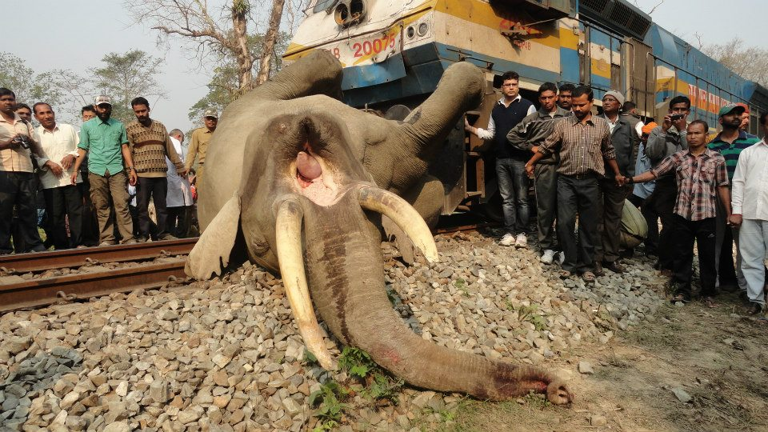
Not even elephants can stand a chance against railroads (Elephant).

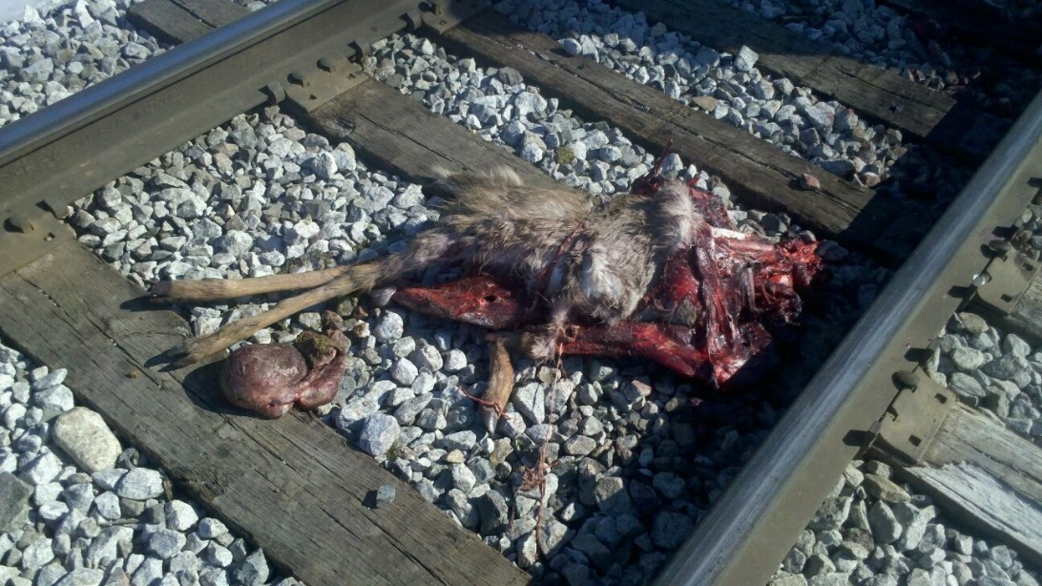
Not only are livestock at risk from train collisions, but wildlife as well. Herds of deer, flocks of turkeys and geese, and every other animal in the way would be at risk. The entire ecosystem of the Midwest would be in jeopardy. Whole species’ populations could decline, impacting others in the process. It is estimated that Alaska’s Elk population declined 70% due to train collisions (Ree et al). If that kind of impact were to happen to the native white-tailed deer population there would be extreme consequences, not only the unnecessary loss of biodiversity, but also for the local infrastructure. In 2012, Wisconsin alone issued over 473,000 deer hunting licenses -adding approximately 1 billion dollars to Wisconsin’s economy (Lazich). That is just the revenue from deer hunting. Wisconsin is also a prime location for turkey, duck, goose, coyote, small game, and a variety of other management programs. All of these populations would be at risk from the projected railroad, as well as the economies associated with them.
Remains of a deer hit by a train (Deer).

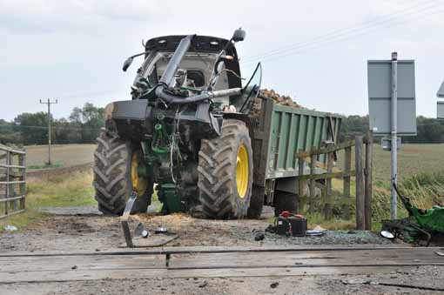
The carnage doesn’t end there, people would also be at risk for death by train. According to the Federal Railroad Administration Office of Safety Analysis, there were 108,963 total train related accidents which resulted in 6,804 deaths (Ten Year). The prospected GLBR project would put many people at risk for unnecessary damage, injury, and death. This risk is increased for farmers, as many would need to cross the tracks to get to the fields the railroad would split apart. The tractors and equipment the farmers need to operate are very loud making it hard to hear oncoming trains, often are pulling heavy loads, and move at a reduced speed. Farming is already one of the most dangerous jobs around, and there is no need to add extra risk to the people working to feed the world. Let the pictures speak for themselves.
White Tails aren’t the only Deer at risk (John Deer).
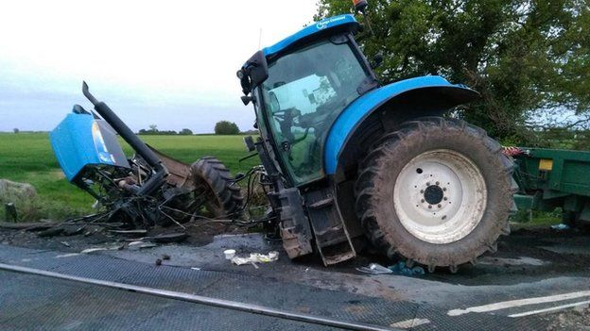
One of the many Tractor vs. Train Accidents (Tractor)
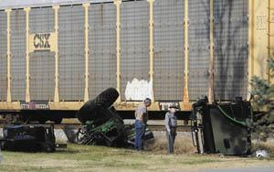

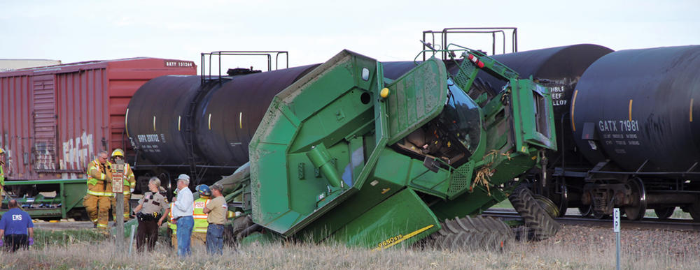
A Fatal Train Accident (Fatal).
Another Train Wreck (Combine).
References

"Great Lakes Basin." Great Lakes Basin. Surface Transportation Board, 8 Apr. 2016. Web. 08 May 2016. https://www.stb.dot.gov/stb/environment/key_cases_GreatLakesBasin.html

Ree, Rodney Van Der, Daniel J. Smith, and Clara Grilo. "Ecological Effects of Railways on Wildlife." Handbook of Road Ecology. N.p.: n.p., n.d. 219-27. https://www.researchgate.net/publication/282152057_Ecological_Effects_of_Railways_on_Wildlife
Wright, Jerry, and Gary Sands. "Planning an Agricultural Subsurface Drainage System." : Agricultural Drainage : University of Minnesota Extension. University Of Minnesota, n.d. Web. 08 May 2016. http://www.extension.umn.edu/agriculture/water/planning-a-subsurface-drainage-system/
"Track Performance." - Railway Substructure Engineering. N.p., n.d. Web. 08 May 2016. http://railwaysubstructure.org/railwiki/index.php?title=Track_Performance
Stevens, Susan. "Lots Of Questions, Some Answers At Great Lakes Basin Railroad Meeting." WNIJ and WNIU. Northern Public Radio, 3 May 2016. Web. 08 May 2016. http://northernpublicradio.org/post/lots-questions-some-answers-great-lakes-basin-railroad-meeting
Waterman, E., I. Tulp, R. Reijnen, K. Krijgsveld and C. Braak. 2002. Disturbance of meadow birds by railway noise in The Netherlands. Geluid http://www.icben.org/2003/pdf/106_t7.pdf

"Minnesota Operation Lifesaver, Inc. : How Long Does It Take a Train to Stop?" Minnesota Operation Lifesaver, Inc. : How Long Does It Take a Train to Stop? Minnesota Safety Council, n.d. Web. 08 May 2016. http://www.minnesotasafetycouncil.org/OL/stop.cfm
"Kent Train Derailed after Hitting Herd of Cows." BBC News. BBC, 27 July 2015. Web. 08 May 2016. http://www.bbc.com/news/uk-england-kent-33671351
"Indian Train Kills Elephants Crossing Tracks." The Guardian. The Guardian, 14 Nov. 2013. Web. 5 May 2016. http://www.theguardian.com/world/2013/nov/14/indian-train-kills-elephants-crossing-tracks
"23 Elk Killed When Train Hits Herd." Washington Times. The Washington Times, 31 Dec. 2015. Web. 08 May 2016. http://www.washingtontimes.com/news/2015/dec/31/23-elk-killed-when-train-hits-herd
Lazich, Mary. "Deer Hunt Benefits Every Wisconsinite." Deer Hunt Benefits Every Wisconsinite. Wisconsin DNR, 15 Nov. 2012. Web. 08 May 2016. http://legis.wisconsin.gov/senate/lazich/PressReleases/Pages/Deer-Hunt-Benefits-Every-Wisconsinite.aspx
"Ten Year Accident/Incident Overview." 1.12 - Ten Year Accident/Incident Overview. Federal Railroad Administration Office of Safety Analysis, 8 May 2016. Web. 08 May 2016. http://safetydata.fra.dot.gov/OfficeofSafety/publicsite/Query/TenYearAccidentIncidentOverview.aspx

Images Cited

Proposed Great Lakes Basin Rail Line. Digital image. N.p., n.d. Web. 8 May 2016. https://1.bp.blogspot.com/-UGy9MNSZdA8/VvKgm4w1YiI/AAAAAAAAExI/ri0aaYtVEsUwwy9_7KZ7_sEM1McKLaiLg/s1600/Eminent%2Bdomain-biz-great-lakes-basin-rail-line-graphic.jpg
Basic Track Components. Digital image. - Railway Substructure Engineering. N.p., 2 Jan. 2013. Web. 8 May 2016. http://railwaysubstructure.org/railwiki/index.php?title=File:Basic_Track_Components.png
Vander Veen, S. Drawing of a Tile Drainage System. Digital image.Operating and Maintaining a Tile Sytem. Ontario Ministry of Agriculture, Food, and Rural Affairs, 4 Jan. 2016. Web. 8 May 2016. http://www.omafra.gov.on.ca/english/engineer/facts/10-091.htm
Cattle Hit By Train. Digital image. N.p., n.d. Web. 8 May 2016. http://www.tribuneindia.com/2012/20120206/bth1.jpg
Elephant Hit by a Train. Digital image. N.p., n.d. Web. 8 May 2016. https://4.bp.blogspot.com/-i4t_5JJ5e8g/UTde6kAtgpI/AAAAAAAADSw/zURSVVNfR3Y/s1600/Elephant+death+rail+05032013-D.jpg
Elephant Hit by a Train. Digital image. N.p., n.d. Web. 8 May 2016. https://4.bp.blogspot.com/-i4t_5JJ5e8g/UTde6kAtgpI/AAAAAAAADSw/zURSVVNfR3Y/s1600/Elephant+death+rail+05032013-D.jpg
Deer vs. Train. Digital image. N.p., n.d. Web. 8 May 2016. https://i.imgur.com/6RpaY.jpg
Tractor Hit by Train. Digital image. N.p., n.d. Web. 8 May 2016. http://ichef-1.bbci.co.uk/news/624/media/images/83011000/jpg/_83011970_c215d990-7675-43af-a250-62fa39861b63.jpg
John Deer Vs train. Digital image. N.p., n.d. Web. 8 May 2016. http://assets.fwi.co.uk/5232425-train1.jpg
Fatal Tractor vs Train. Digital image. N.p., n.d. Web. 8 May 2016. https://bloximages.chicago2.vip.townnews.com/bgdailynews.com/content/tncms/assets/v3/editorial/a/59/a5974457-8dd4-5825-a738-1a2e5521e825/4f64162a2eb97.image.jpg
Combine vs. Train. Digital image. N.p., n.d. Web. 8 May 2016. http://www.dglobe.com/sites/default/files/styles/full_1000/public/field/image/TrainCombineRGB.jpg?itok=EVzgQLsl

