ATTENTION: Dave Navecky
Surface Transportation Board
395 E Street SW
Washington DC 20423-0001
Docket No FD-35952
FROM: Kristin Andrysiak
688 E 700 N
Westville, IN
219-629-6381
RE: GLBR Concerns

APRIL 12, 2016
CONCERNS:
Noise and Vibration pollution (see Exhibit 1)
There must be an alternative route that doesn’t come within ¼ mile of our small community in eastern Jackson Township. There are six residences within ¼ mile and even more within a ½ mile of the proposed tracks. I fear the noise and vibration pollution at this distance will be unbearable and severly affect our quality of life. I would hardly call our little community sparsely populated.
Town of Westville strangled (see Exhibit 2)
As proposed there are two spurs that head east out of Porter County and into Laporte. One to the north and one to the south of Westville. There must be an alternate route to Laporte through southeast of Westville that is more effective and does not strangle the town. As proposed, the town will be surrounded by 4 crossings at major roads Route 6, Route 2 and 421. This is not only concerning asthetically, our small town now surrounded by frieght trains, but also what will our emergency reponse times be for those living outside of town limits? The increased number of crossings on major state roads will certainly increase the risk of accidents at train gates.
Why are City of Chicago train inefficiencies becoming the problem of 11 other farmland counties?
Have all other options been exhausted and thoroughly researched before deciding it is necessary to destroy farmland in 11 counties unnecessarily? Cannot we find more effieciency throgh upgrading existing infrastructure? This expansion currently seems very inconvienent to the 11 counties it will affect but also not necessary to solve the inefficiency problem when other options exist.
What about this program? http://www.createprogram.org/index.htm
“CREATE is a first-of-its-kind partnership between U.S. DOT, the State of Illinois, City of Chicago, Metra, Amtrak, and the nation's freight railroads. A project of national significance, CREATE will invest billions in critically needed improvements to increase the efficiency of the region's passenger and freight rail infrastructure and enhance the quality of life for Chicago-area residents.”
Potential for pollution with the major portion of rural Porter County on well water
The majority of the proposed railroad runs through rural areas who rely on well water. It would only take one derailment and spill to contaminate our water supply rendering our wells (and therefore our property) useless. It would be a major undertaking, if not impossible to get the entire rural community on city water. This is of particular concern to me with the proposed train currenlty only ¼ mile from my property.
Safety and Funding – local fire departments are not equipped
Our local fire departments are not equipped to handle a derailment or hazardous spill. Who will fund the cost of getting them ready? Will the GLB investors be training our local first reponsders and supplying them with the necessary equipment or will the local communities each have to fund the these costs out of pocket?
High Speed Freight in close proximity to a prison (see Exhibit 3)
While there hasn’t been an escape from the Westville Prison since 2007, it just doesn’t seem smart to put a railroad within a ¼ mile of prison property. I am sure the inmates know that they currently can’t get very far before they will be found; however, adding a railroad so close to the prison walls certainly complicates things. Will escape become easier and therefore more tempting?

Exhibit 1: Noise and Vibration pollution
Several residences less than ¼ mile from proposed route
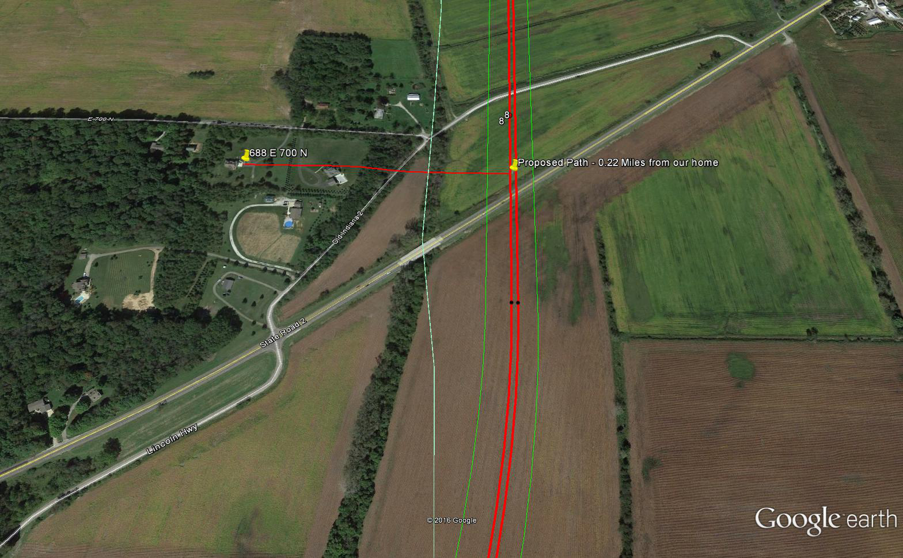
Kristin Andrysiak and Chris Boggs, 688 E 700 N, Westville, Porter County, Indiana
Exhibit 2: 4 major crossings surrounding the Town of Westville
Crossings at Route 2, Route 6 and SR 421 twice
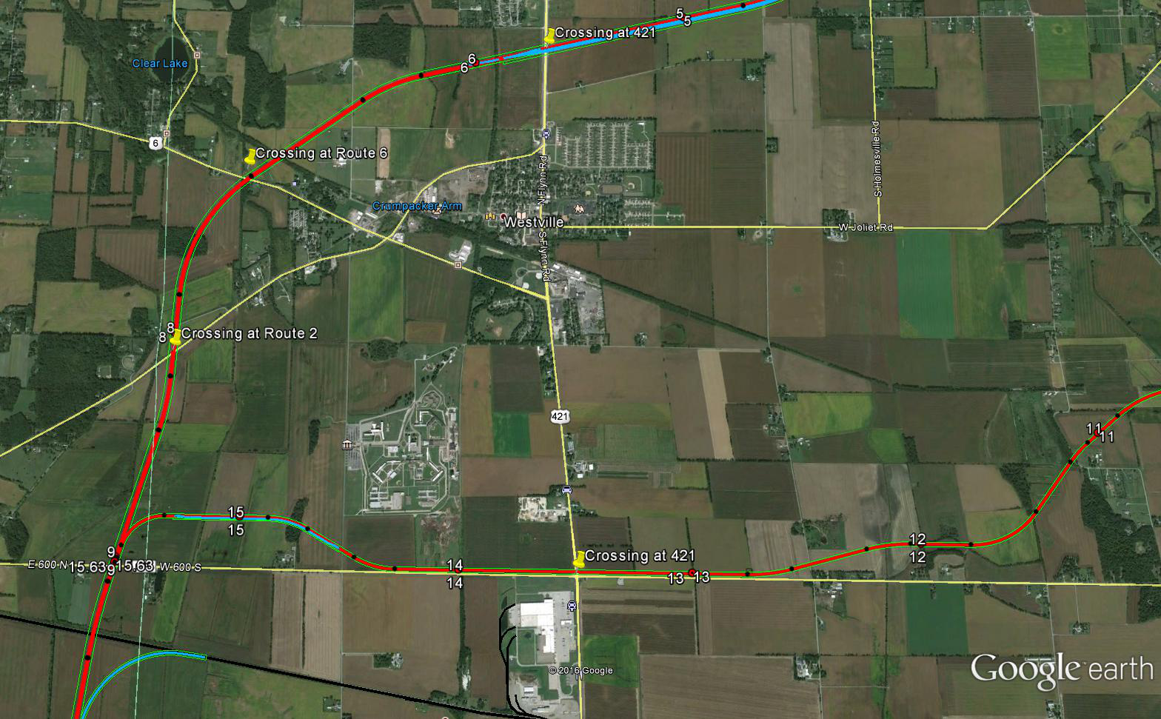

Exhibit 3: Proximity to Westville Correctional Center
