November 16, 2015

Catherine Nadals
Environmental Protection Specialist
Office of Environmental Analysis
Surface Transportation Board
Washington, D.C. 20423

Re: Docket No. AB55 (Sub-No. 745X)
CSX Notice of Exemption- Track Abandonment
Prestonsburg to David, Floyd County

Ms. Nadals,

The Kentucky Department for Environmental Protection has reviewed this project on multiple occasions and has concerns in regards to the CSX’s statement to leave all trail related structures, such as bridges, trestles, culverts and tunnels in place. This portion of Floyd County has a high rate of flooding. Since failure to implement proper maintenance can cause additional flooding issues for local landowners, the Division of Water (DOW) would be open to either removal of the structures and remediation or development of a maintenance plan of action. This action plan should detail how CSX intends to maintain these areas in good condition to keep them free of drift and debris (KRS 151.250, 401 KAR 4:060 Section 3(1)). DOW would still require a maintenance requirement even if CSX removes the line since CSX previously received authorization from DOW for the installation of these structures.

This review is based upon the information that was provided by the applicant.

If you should have any questions, please contact me at (502) 564-2150, ext. 3125.

Sincerely,
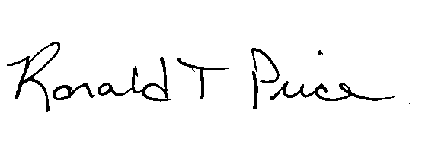
Ronald T. Price
State Environmental Review Officer
Kentucky Department for Environmental Protection

