Walnut Grove Farms, L.L.C.
34695 Kirkland Road
Kirkland, Illinois 60146

May 31, 2016

Mr. Dave Navecky
Surface Transportation Board
Docket No. FD 35952
395 E. Street NW
Washington, DC 20423-0001

RE: Docket No. FD 35952- Great Lakes Basin Transportation, Inc.
Dear Mr. Navecky,

Thank you for providing the opportunity to submit comments on Docket No. FD 35952- Great Lakes Basin Transportation, Inc.- Authority to Construct and Operate a Rail Line in Indiana, Illinois, and Wisconsin.

Per your letter date March 18, 2016, the Great Lake Basin Transportation, Inc. (GLBT) plans to file either a petition for exemption pursuant to 49 U.S.C. § 10502, or an application pursuant to 49 U.S.C. § 10901, seeking authority from the Surface Transportation Board (STB) to construct and operate an approximately 278-mile rail line from generally La Porte, Indiana through Illinois to near Milton, Wisconsin. The rail would connect with existing Class I railroads.

The proposed 278-mile railroad will result in significant environmental impacts; therefore, we are requesting that the STB deny the GLB’s petition for exemption pursuant to 49 U.S.C § 10502 and require the proposal to undergo a full review.

Over 150 river and creeks are crossed by the proposed rail line. These include high quality systems such as the Kishwaukee, Lower Fox, and Kankakee Rivers as well as over 100 headwater streams that are critical for sustaining healthy plant and animal habitat downstream. The rail line would also impact the mottled sculpin and ellipse mussel, who reside in these waters.

The proposal would also slice farmland in two- including our family farm, destroy drainage tiling, create dead-end rural roads and block critical surface water. Our Crain Road farm (picture provided below) is part of our third generation family farm. We’ve spent the past 30 years building our soil structure through crop rotation, cover crops, and in-line ripping.

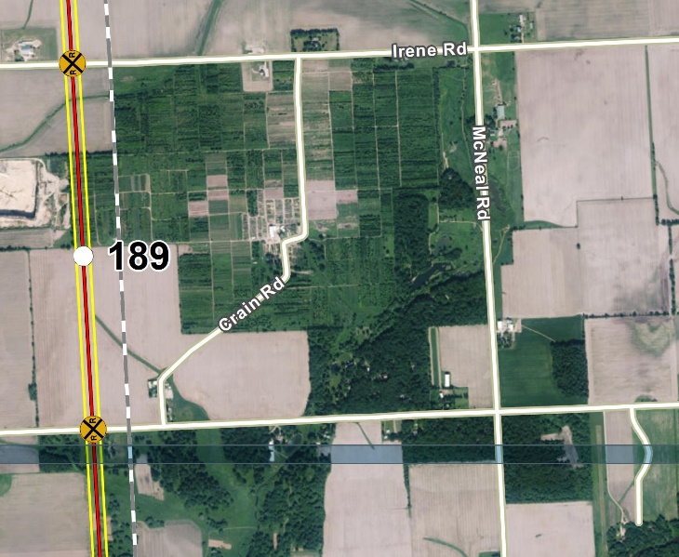

Rather than slicing farmland, existing rail lines should be upgraded and improved. Chicago, to date, remains the busiest rail hub in the United States. Each day, nearly 1,300 trains pass through the region. Chicago handles one‐fourth of the nation's freight rail traffic, each day handling 37,500 railcars. For almost 150 years, Chicago has been the nation's rail hub due to its critical location at the nexus of the North American railroad network. Six of the seven largest rail carriers access the region: the eastern railroads, NS and CSX; the western railroads, BNSF and UP; and the American subsidiaries of the two Canadian railroads, Canadian Pacific (CP) and CN.

However, the rail lines built more than a century ago are not configured for the volumes and types of freight being carried currently, and Chicago has become the largest U.S. rail freight chokepoint. Rather than expending eight billion dollars to take private property, destroy family farms, and potentially damage high quality environmental systems those funds should be used to improve upgrade existing railways.

Additionally, funds could alternatively be expended to improve the inland waterways system. The U.S. Army Corps of Engineers estimate that the values of the infrastructure that supports inland waterways to be more than $260 billion. The inland waterway system has existing infrastructure; therefore, the use of eminent domain may not be needed.

Sincerely,
Jeff and Bona Heinsohn

